IT 700: Capstone in Info Technology

9 – 2 Capstone Component 2 – IT Project Report Submission

Electronic Hospital Management System for Developing Countries

*(Using Nigeria, West Africa as a case study)*

Jeremiah Abah

Southern New Hampshire University

October 2019

Table of Contents

IT 700: Capstone in Info Technology 1

SECTION 1: PROJECT DESIGN 4

Problem Statement 4

Overview of Solution 5

Methodology 6

Adaptation Plan 6

Method of Data Collection 7

System Design 7

Input Analysis 8

Process Analysis 8

Output Analysis 8

Tools 8

Software Requirements 8

Hardware Requirements 9

Requirements 9

Functional Requirements 9

Security Requirements 9

Performance Requirements 10

Gap Analysis 10

Compliance 10

Sarbanes-Oxley Act (SOX) 11

Health Insurance Portability and Accountability Act (HIPAA): 11

Payment Card Industry Data Security Standard (PCI DSS): 11

Analysis of Problem 11

Significance of Problem 12

Stakeholder’s Needs 12

Overview of the Design 13

Registration System 13

Database Management System 13

Reporting System 13

SECTION 2: PROJECT IMPLEMENTATION 14

SECTION 3: PROJECT TEST PLAN 15

Summary 16

SECTION 4: RECOMMENDATIONS FOR FUTURE ENHANCEMENTS 17

Successes, Challenges, and Lessons Learned 17

Challenges: 17

Lessons Learned: 18

Modification Strategies and Actionable Steps 18

Potential Issues 19

Future Enhancements 19

SECTION 5: APPENDIX 21

Figures 25

References 34

# SECTION 1: PROJECT DESIGN

## Problem Statement

Recent times has seen a continuous widespread and adoption of various technologies all around the globe. It is interesting to see that with the growth of technology and its adoption in various countries, comes to light many obvious or sometimes hidden challenges that has always existed in such locations. In developing countries, especially in West Africa, the health systems can leverage these technologies to build stronger and easily accessible health care for their citizens. In this project, I have identified the problem of an Electronic Hospital Management System for Developing Countries. This is still lacking in most African countries as of today.

The significance of having a stable and efficient Electronic Hospital Management System in developing Countries cannot be overemphasized. This problem makes it difficult for patients to go online and book appointment with Doctors. They usually have to do a walk-in hospital visits and wait in long cue for hours to be attended to; sometimes they have to come back the following day before it gets to their turn to see the Doctor on call. From personal experience in a country in West Africa, this is a highly needed technology that will help solve the challenges faced by individuals as well as the hospital staff who’s challenges include over reliance on paper based record keeping methodology which leads to loss of patient and staff records, consumption of office space, time consuming process of collecting, processing and retrieving patient details, and sharing of vital information between various departments within the hospital as a result of poor information management.

## Overview of Solution

The solution to the above stated problem is to build a comprehensive Hospital Management System that will cater for all the aforementioned challenges in different ways. This system will be an intelligent hospital information management system developed to assist the patient even before the get to the hospital with needed information about the doctors, appointment times, relevant departments, laboratory tests and the specific medicine about his/her medical situation.

The Hospital administrative personnel will also benefit tremendously from the system because it will assist them with acquiring, processing, and managing the patient's clinical information. Such Hospital information system will provide a major part of the information needed by companies such as health insurance and organizations that pay for health car. Hospital staff at the front desk or administrators will easily have access to patient information, and they can to store and manage various resources according to patients and doctor's requirements using this system. This will include details such as room and bed availability, normal/ICU accommodation availabilities, management of billing details and hospital stock inventory. For the administrators, this system will enable them to computerize all employee records and as well manage the financial expenses of both employee and the hospital.

The system will also provide software assistance for the doctors to diagnose easily and rapidly by using the program's decision mechanism.

The next elements to be considered in this proposal will include various laws, standards, country legislation and existing regulations that are in place that this project will need to be in compliance with. We will also consider elements such as the methodology, tools and system requirements as well as user requirements from the hospital staff perspective and the patient’s requirements.

## Methodology

This deals with the details of how the research and collection of various data needed for designing and building the database is done. We will start out with an adaptation plan, data collection methods, analysis of Input, Process and Output Analysis.

### Adaptation Plan

In this phase of the planning, various elements are considered which include details such as the requirements of the hospital employees and physician for the Electronic Hospital Management System:

* Various Data fields required
* Detail of information to be entered by staff
* Kinds of reports required by management for business decision making.
* Kind of patient data required for medical examination by the physicians.

Study of the workflow in the hospital should be done after these required data is collected, either through one on one interview with doctors and nurses or from existing documents. Any limitations should be listed and properly considered in the proposed system (Workflow Adaptation, 2019).

A case study hospital is the General Hospital in Abuja Nigeria where manual processes are still being used to record various data and store them. Some of the drawbacks of such systems include:

* Time consuming in filling, searching and retrieving of needed data.
* Data security is very poor.
* Tendency for misplaced or mixed up patient’s files.

The introduction of Electronic Hospital Management System helps overcome most of these challenges for instance; cloud storage of patient’s medical records, electronic billing maintained online and retrievable when needed, generating various online reports when needed, accessibility of various information to both doctors and patients. All of the above benefits help reduce the margin for errors and increase the efficiency of the healthcare services provided.

Method of Data Collection

Two categories of data collected for this project are Primary Data (directly from Doctors and hospital staffs through one on one interviews and filling a survey form) and Secondary Data (from websites which include Health IT.gov and HER.

## System Design

From the gathered user requirements, a good system design is depicted by the figure below. According to Odhiambo (2018), System design is the process of designing the elements of a system such as the architecture, modules and components, the different interfaces of those components and the data that goes through that system.

System design also describes the process of developing, expressing, documenting, and communicating the realization of the architecture of the system through a complete set of design characteristics described in a form suitable for implementation (SEBoK, 2019). The main purpose of System Design is to supplement the system architecture by providing useful and necessary information and data for the various system elements’ implementation.

### Input Analysis

This analyzes the inputs from nurses and hospital staff and it includes details such as Name, age sex address, phone number etc. Those of patients and doctors are also collected.

### Process Analysis

The inputs collected are processed and used to determine the logical database model for the system.

### Output Analysis

This determines the various reports to be generated from the system after all processing are done.

## Tools

Development tools refer to the software needed to design, build and test the Hospital Management System project. While many options are available today, our choices will be based on robust features, scalability and efficiency of tools being used. Below are the software and hardware requirements:

### Software Requirements

* Operating System will be a Windows 10 OS.
* I will be using the IntelliJ IDEA (Java IDE) to develop this project. Its Ultimate edition is intended for web and enterprise development and it supports JavaScript and TypeScript; Java EE, Spring, GWT, Vaadin, Play, Grails, and other frameworks; and includes database tools and SQL support.
* Microsoft SQL will be the DBMS for this project due to its scalability and robust features.
* Bitdefender Complete enterprise protection package.

### Hardware Requirements

* Storage: 1TB hard drive.
* Memory: 16gb of RAM
* 27’’ colored monitor
* Intel CORE I7 AND ABOVE.
* Printer: HP colored and black & white.

## Requirements

### Functional Requirements

* To provide the history of patients’ health.
* To generate electronic bills payable online.
* Platform for searching doctors’ availability and online booking of appointments.
* Generating electronic lab reports viewable by patients and assigned doctors.
* Provide the option for insurance details to be filled in the waiting room.
* Check the availability of prescription in pharmacy inventory.

### Security Requirements

* Only authorized hospital personnel are granted access to the system or data.
* Doctors are given access to view and review only their assigned patient’s data.
* Prescription details of a patient should be kept private to only patient’s family.
* Only authorized persons should have access to Billing information.

### Performance Requirements

* There is expected to be a reduced Pharmacy calls regarding prescription by 60% in about a month of the systems’ implementation.
* Wait time of Patients is expected to reduce by 70% after the first month that system goes live.
* System efficiency and uninterrupted flow of work is of high essence.

### Gap Analysis

A major issue found in the present system is the long wait time for lab reports to reach the patients. This system will by pass a lot of the process involved in the traditional system of generating lab reports. Reports will directly be uploaded from the labs in this system and be made visible to Patients and assigned doctors thereby reducing the wait time by about 50%.

This system will also cater for the second issue which is booking of appointments with doctors. Patient’s ability to check doctor’s availability online and select/confirm their preferred appointment time will be a great improvement over the traditional system.

### Compliance

There exist many regulatory laws and standards that deal with the issue of data protection, administration and management. A few mentioned below are applicable in the US. The developing countries will equally have similar standards that will be applicable at deployment and therefore, efforts are being made to get all their requirements before the end of this project.

### Sarbanes-Oxley Act (SOX)

A U.S. Public Accounting Reform and Investor Protection Act of 2002, which regulates various organizations, helping to reduce fraud related to financial reporting and disclosures

### Health Insurance Portability and Accountability Act (HIPAA):

Focused on how hospitals must protect the health care information of all patients, they conduct frequent audits to ensure all hospitals doctors’ offices are in compliance with all requirements of the regulations put in place.

### Payment Card Industry Data Security Standard (PCI DSS):

This ensures the protection of credit cards against hackers, various online fraud and security issues on social media platforms (Mullins, 2012).

## Analysis of Problem

A major problem identified with the traditional hospital management system in developing countries is its’ manual system which are prone to multiple grievous errors and inaccuracies in reports generated. There are no options for online booking of appointment thereby requiring patients to physically visit the hospital to schedule an appointment. The manual entry system of inputting data is time consuming and payments cannot be accepted online. Furthermore, patients always have to carry along every medical report and prescriptions to every appointment for the doctor to see and analyze. The proposed Electronic Hospital Management System will provide a robust, stable and more permanent solution to all the problems identified above.

### Significance of Problem

The current system highly characterized by time-consuming processes of maintaining records, massive database and lots of paper works to deal with. The use of paper works for hospital records, database and banking processes is prone to affect productivity and coherence of records which are likely to get mixed up or lost in the process. Large space is required for storage of files in huge file cabinets and ultimately, searching for or retrieval of patients’ previous health records becomes highly tedious for the hospital staff to go through all the cabinet in search of such files. There is also the lack of security of sensitive records. Finally, patient’s inability to check Doctors’ availability and book appointments online demands commuting to the physical location of the hospital to schedule an appointment and fill all required forms such as insurance & billing, health history and basic personal profile such as address, phone etc. This adds up to the patient’s wait time in hospitals because there is hardly a known set time for their appointment even on the given day; they usually have to wait minimum of 30 minutes to an hour or more depending on the traffic volume of patients scheduled to see the doctor on that day.

### Stakeholder’s Needs

Patients require a system that supports online appointment booking, checking a specific doctor’s availability, provision for online bill payment and reduced wait time in hospitals.

Doctors require a system on which they can check each patient’s previous history of health, access health reports and as well monitor the health status of current patients.

Hospital Staff require a system that supports fast and efficient data input, processing, storage and generating electronic bills made payable online by patients.

Executive Board of Trustees require a system that enables them monitor administrative activities of the hospital and generate various departmental or quarterly reports which support informed business decision making (Kumar, 1998).

## Overview of the Design

Three sub divisions will be used to divide the HMS and made viewable separately.

Registration System– mainly for office use (Hospital staff) with each assigned a uique ID number for login. This will contain several forms used for data collection from other stake holders. Examples of such forms include *Patient Form* – in which the patient details are filled, usable by in patients and out patients for doctor’s use in the diagnosis. *Adding Doctor Form* – is the form used for adding new doctors to the database of the hospital and it contains all personal information about the doctor.

Database Management System – Containing all tables for storing data from all forms used in various departments in the HMS.

Reporting System – Mainly used in generating all required reports from various departments useful for management decision making.

# SECTION 2: PROJECT IMPLEMENTATION

My project, creation of an Electronic Hospital Management System, aimed at providing a robust, scalable and stable system to serve as a more permanent solution to most of the problems faced by third world countries’ health care ministries, will involve creating multiple web portal and database for the different stakeholders/users of the system. The different stages outlined below show more details:

* Stage 1- Initial patient web portal with the online forms for searching doctors’ availability and scheduling online appointments. This portal will also include ability to collect some basic patient health history.
* Stage 2- This stage focuses on the creation of the physical database model for the HMS. The form filled to by users to populate the database will request for details such as Name, date of birth, preferred appointment date and time, previous appointment, and an auto-generated unique ID number. Additional health related history will be required of patients to give as much details as possible to enable the Physicians have a head start on the diagnosis for each patient even before the scheduled appointment date.
* Sage 3 – will focus on the creation of web forms for collecting details of patient’s health history, database users’ information and authentication script for all users of the database and script for extraction and addition of data to the main database from various forms.

# SECTION 3: PROJECT TEST PLAN

Considering the nature of my project, it is obvious that it has an intensive dependence on user/stakeholder feedback to determine the best outcome, if their needs are met with the provided solution in the project or not. With this being a heavy user interactive System, incorporating tests will help ensure the exploration of any possibilities of functionality errors, data input errors, overall layout and easy flow of data and user experience. Hence the test plan for this project involves the use of three different types of tests, namely JUnit testing, functional testing and usability testing (UX Testing).

According to Rouse (2010), JUnit testing involves re-writing just enough code required to make a failed test pass, fostering an environment for test-driven development, thus pinpointing functionality of code. The second test I will use is the Functional Testing which adds another layer on top of the outcome of the JUnit testing. Just as the name implies, Functional testing is a type of software testing whereby the system is tested against the functional requirements/specifications. This is achieved by the use of a black-box testing technique to further ensure that the requirements are properly satisfied by the application.

Lastly, I will be using “usability testing” to ensure the user-friendliness of the system with real users in a chosen Hospital environment. This is focused on getting user-feedback from users who are asked to complete tasks on the system while being observed and final recommendations made to help overcome such usability issues. The usability testing will incorporate the testing of the various forms as well to see how fast and efficient they are at the backend for generating the needed reports for the Hospital management, Doctors, nurses, hospital staff and database administrators.

## Summary

The project implementation and testing plans must be carried out concurrently to ensure that no aspects of the development phases are left untouched or omitted. Having the database built using MySQL guarantees a robust database which will be primarily responsible for the collection of various data from all users. I will be using JSP (JavaServer Pages) technology to create the dynamic web-based applications integrated with the database.

# SECTION 4: RECOMMENDATIONS FOR FUTURE ENHANCEMENTS

## Successes, Challenges, and Lessons Learned

My project, creation of an Electronic Hospital Management System, aimed at providing a robust, scalable and stable system to serve as a more permanent solution to most of the problems faced by third world countries’ health care ministries, has been a major success in many areas including completion within the specified time frame and within budget. Hence, the timeline, budget and meeting of user requirements are the key factors used in determining the successes of this project. Furthermore, the qualified production team on this project was a great factor in ensuring everything was done in a timely fashion, thus enhancing the effectiveness of the technology evaluation, project planning, and execution.

### Challenges:

A major challenge faced as a developer was trying to be in charge of both the backend and frontend development at the same time considering all the various factors and user requirements. For future projects, more developers should be involved to ensure less stress on one or two developers considering various aspects of development needed for the same project.

Secondly, lack of proper management of change processes by the organization was another challenge faced by this project. When the management decides a change process without factoring in the opinion of other stakeholders, who are primary users of the system being built; this could lead to anxiety in the implementation process (Per Tarnow, 2002).

### Lessons Learned:

In terms of lessons learned, the importance and effectiveness of good planning, support from management and effective communication were all factors geared at the success of this and for future enhancements (Loughry and Thatcher, 2004). Of great importance are the technical knowledge acquired the duration of this project; being able to implement project management skills as well as the skills of a full stack developer to meet all client needs is highly satisfying. Thinking about compliances as a developer, ensuring that the software or system meets every regulatory standard such as the HIPAA for the health sector was another important lesson learned.

## Modification Strategies and Actionable Steps

Modification strategies for this project include reaching out to big companies such as WHO to get their buy-in on this project, make available needed resources and funds for scaling this project to meet the required standard for other countries to adopt. But before then, there is the need for ensuring the stability of the current system as it gets used within 6 months to a year bringing in a perfect working relationship among interdepartmental teams who agree to share information and collaborate in problem-solving efforts on this new system (Laudon & Laudon, 2003). A second important strategy based on training programs to ensure sufficient technical know-how of company technicians that will be tasked with the maintenance of this system and be able to train other users within the hospital; this is popularly known as the “train-the-trainer strategy”. It is also good to have data expert personnel within the company to handle issues related to all data generated and data usage within the system.

### Potential Issues

Two potential issues associated with this project are:

* Capital intensive. Achieving this project in full capacity was costly due to the depth of user requirements for the various stakeholders and the availability of resources. Future enhancements will require a thorough feasibility studies and an adequate budget put in place before embarking upon such enhancements.
* Secondly, migration of data from the large paper copies, files and physical folders of thousands of hospital patients into the system is an enormous task to embark upon. Two methods could be employed using dedicated IT staff that will collaborate with the hospital staff in charge of archives of patient information. Using a scanner to scan into the system all the various physical forms already filled by the patients or having to type them in physically.

## Future Enhancements

Considering the ever-changing field of IT, it is very frequent to see new tools coming out at least once or more in a year, depending on the area of focus for a particular technology. These have the ability to completely change how businesses are conducted, and how communication takes place within a given technological domain.

My project was focused on building an Electronic Hospital Management System for Developing Countries especially, Africa. This was a highly needed technology to help solve the challenges faced by individuals in need of healthcare in those countries. This was made possible by the up-soaring easy access to internet being experienced in those countries recently; with the use of smartphones on the increase, Web Applications such as this will be accessible and useful to all stakeholders (Patients, Doctors, and hospital personnel).

Quite a number of new trends exist which may impact my project sometime down the line. For example, some new trends which have emerged in the world of BI and big data will certainly impact my project, including trends in cloud technologies, cyber security, and self-service BI (Top Business Intelligence Trends 2019). Furthermore, new trends within the healthcare industry have also arisen; especially with regards to Healthcare laws and regulations concerning the security of patient private data all over the world. New technologies are being developed and introduced in order to safeguard our privacy and security in this new digital age. Additional restrictions may arise in the laws in the near future aimed at safeguarding these data and this will require revisiting the security specifications used in my project code to see if they are up to date or at par with the government recommendations and Health organization standards. I am confident that these trends will add positively to the dynamic environment of IT, leading to continuous adaptation and more innovations and solution strategies to enhance both the services provided to the masses as well as achieving a better overall quality in the technologies used in the field of Health.

# SECTION 5: APPENDIX

Table 1

Patient Table

|  |  |  |
| --- | --- | --- |
| Column | Data type | NULL |
| Patient_ID | Int | NO |
| Doctor_ID | Int | NO |
| Address_id | Int | NO |
| Services_Id | Int | NO |
| Admission_Num | Varchar(5) | NO |
| F.Name | Varchar(10) | YES |
| L.Name | Varchar(10) | YES |
| Sex | Varchar(6) | YES |
| DOB | Date | YES |
| Blood Group | Varchar(3) | YES |
| Genotype | Varchar(2) | YES |
| Next of Kin | Varchar(20) | YES |
| Guardian | Varchar(20) | YES |
| Health History | Varchar(100) | YES |

Table 2

*Doctor Table*

|  |  |  |
| --- | --- | --- |
| Column | Data type | NULL |
| Doctor_Id | Int | NO |
| Address_id | Int | NO |
| F_Name | Varchar(10) | YES |
| L_Name | Varchar(10) | YES |
| Specialization | Varchar(20) | YES |
| Qualification | Varchar(20) | YES |
| Available Days | Varchar(10) | YES |
| Avaiable From | Time | YES |
| Available To | Time | YES |

Table 3

*Hospital Services Table*

|  |  |  |
| --- | --- | --- |
| Column | Data type | NULL |
| Services_ID | Int | No |
| Blood_Test | Varchar(3) | Yes |
| Maternity | Varchar(3) | Yes |
| EYE_Test | Varchar(3) | Yes |
| Preg_Test | Varchar(3) | Yes |
| X-ray | Varchar(3) | Yes |
| Family_Planning | Varchar(3) | Yes |
| Counselling | Varchar(3) | Yes |

Table 4

*Staff Table*

|  |  |  |
| --- | --- | --- |
| Column | Data type | NULL |
| Staff_Id | Int | NO |
| Address_Id | Int | NO |
| F.Name | Varchar(10) | YES |
| L.name | Varchar(10) | YES |
| DOB | Date | YES |
| Department | Varchar(50) | Yes |

Table 5

*Add Bed Table*

|  |  |  |
| --- | --- | --- |
| Column | Data type | NULL |
| Bed_Num | Int | NO |
| Admission_Num | Int | NO |
| Room_NUM | Int | Yes |
| Type_of_bed | Varchar(10) | Yes |
| Availability | Varchar(3) | Yes |

Table 6

*Billing Table*

|  |  |  |
| --- | --- | --- |
| Column | Data type | NULL |
| Bill_Num | Int | NO |
| Patient_ID | Int | NO |
| Admission_NUM | Varchar(5) | NO |
| Services_ID | Int | NO |
| Amount | Int | Yes |

Table 7

*Address Table*

|  |  |  |
| --- | --- | --- |
| Column | Data type | NULL |
| Address_ID | Int | NO |
| Address_Line_1 | Varchar(10) | YES |
| Address_Line_2 | Varchar(10) | YES |
| City/Town | Varchar(10) | YES |
| State | Varchar(10) | YES |
| Country | Varchar(10) | YES |
| Zip_Code | Int | YES |
| Phone | Int | YES |
| Email_id | Varchar(30) | YES |

Figures

Figure 1

System Design Overview

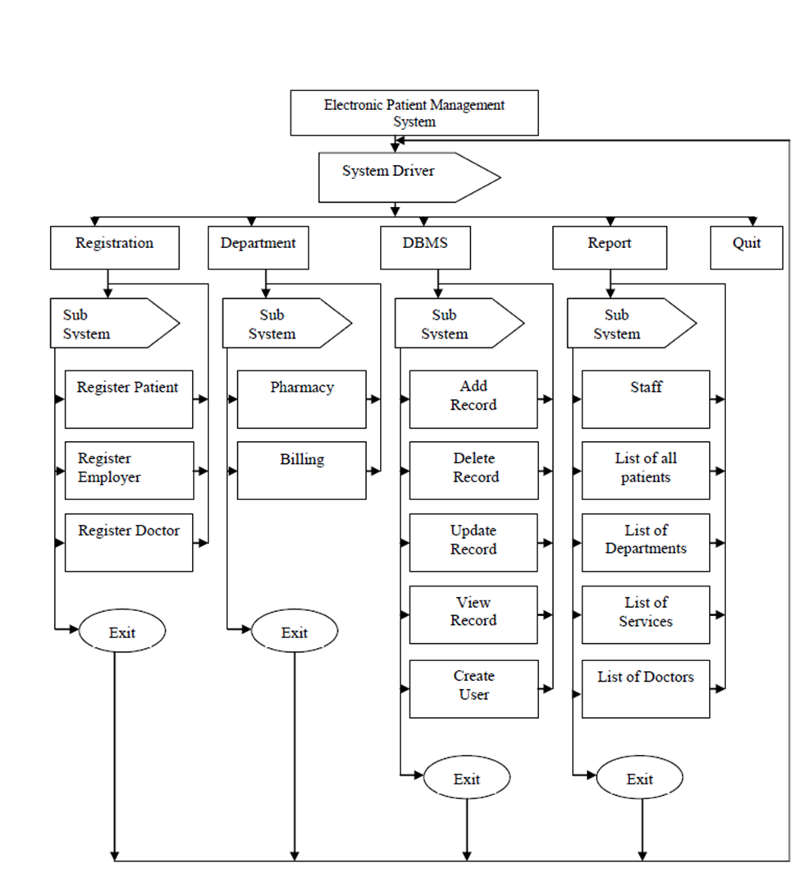

Figure 2

*Entity Relationship Diagram for Patient Management System*

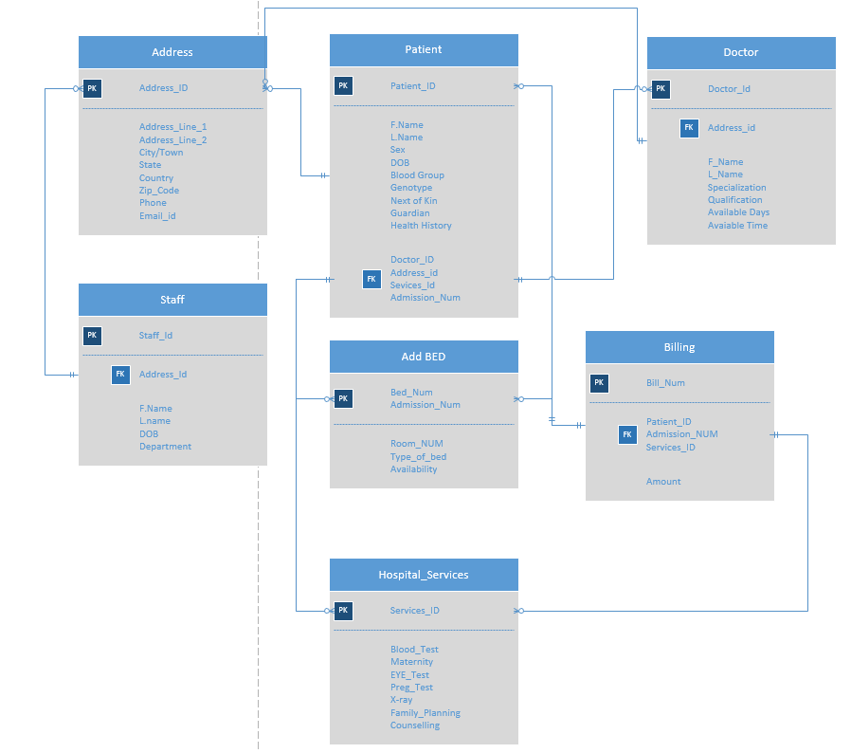

Figure 3

*Program Flow Chart*

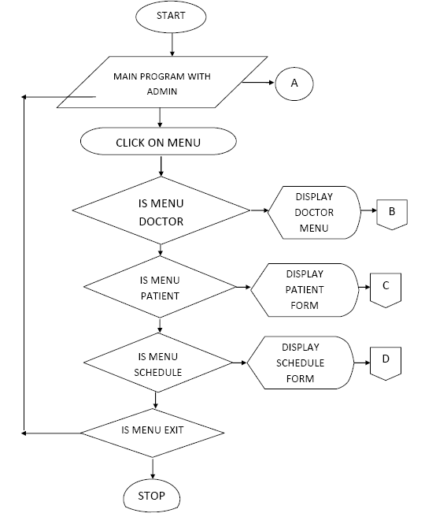

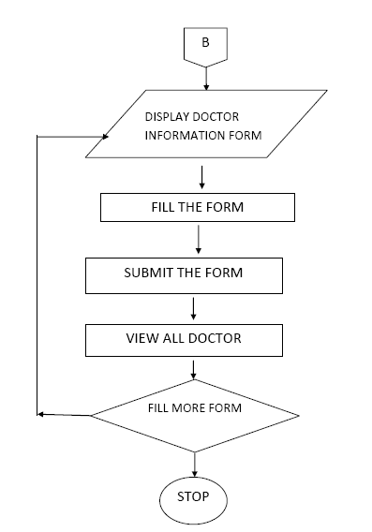

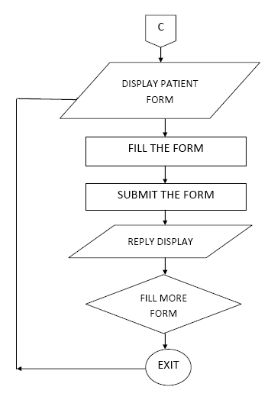

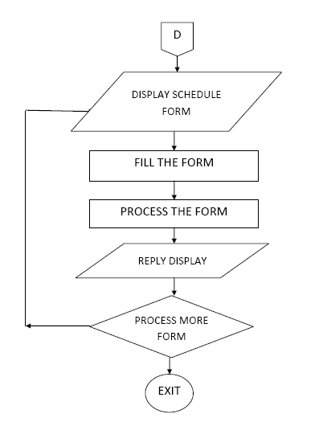

Figure 4

*Main Screen*

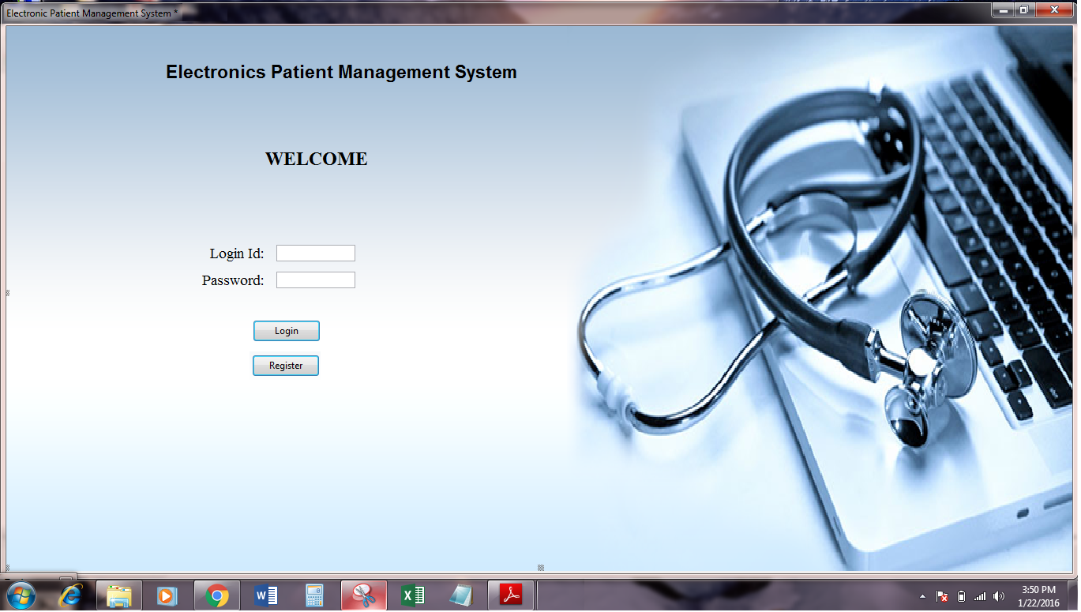

Figure 5

*Doctor’s Details Screen*

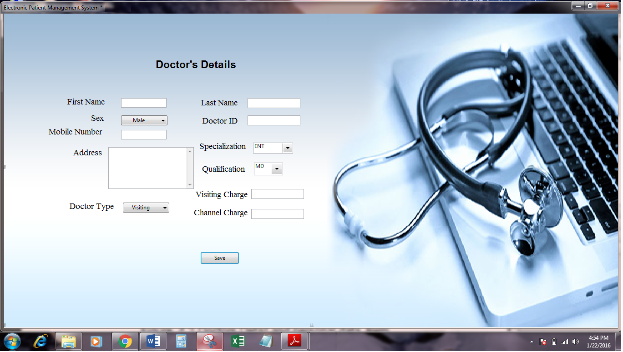

Figure 6

*Doctor’s appointment Screen*

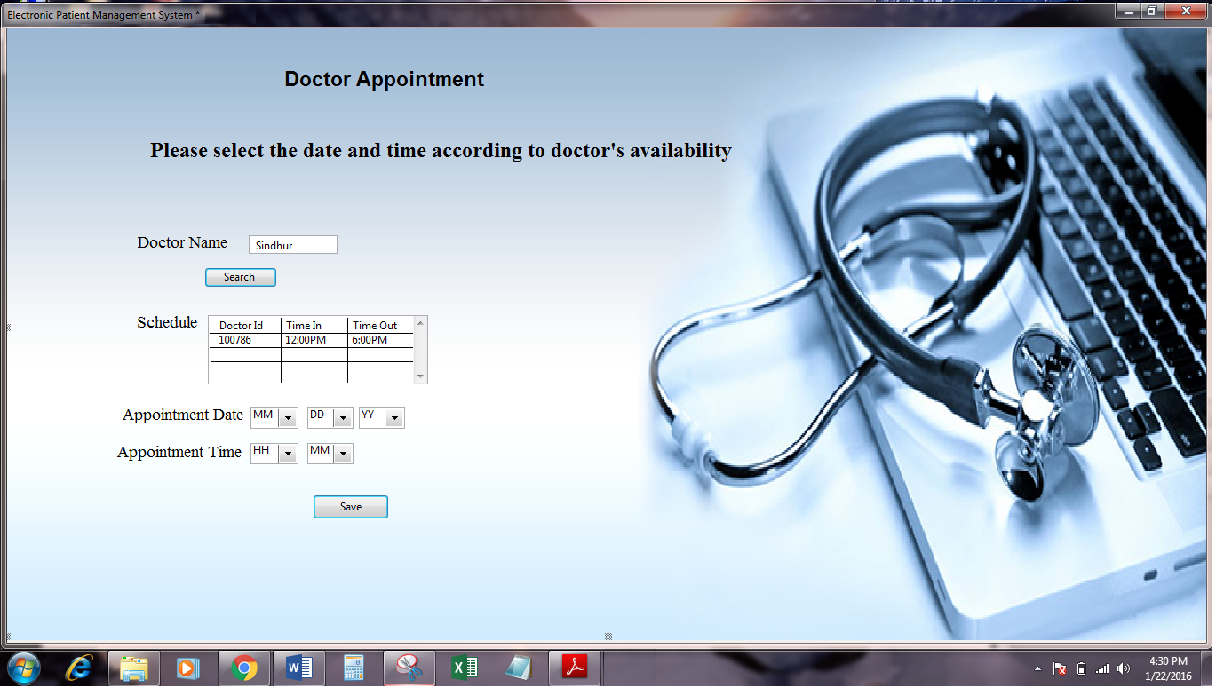

### References

*Benefits of Electronic Health Records (EHRs)*. (2015, July 30). Retrieved from https://www.healthit.gov/providers-professionals/benefits-electronic-health-records-ehrs

Brigl, B., Ammenwerth, E., Winter, A., & Haux, R., (2004, April 7). Strategic Information Management in Hospitals: An Introduction to Hospital Information Systems. Retrieved from https://books.google.com/books?id=FBk8u3nIN_AC&dq=importance+of+hospital+management+system&lr=&source=gbs_navlinks_s

*EHR Implementation Resources*. (2019). Retrieved from https://www.healthit.gov/providers-professionals/implementation-resources?f[0]=ehr-implementation-steps%3A107

*Health IT.gov*. (2019). Retrieved from https://www.healthit.gov/

Heller, M., (2018, December 18). Choosing your Java IDE: Compare Eclipse, NetBeans, and IntelliJ IDEA for features, usability, and project size and typehttps://www.javaworld.com/article/3114167/choosing-your-java-ide.html

Intelligent Hospital Management System (IHMS). (2015). *2015 International Conference on Computational Intelligence and Communication Networks (CICN), Computational Intelligence and Communication Networks (CICN), 2015 International Conference on, Computational Intelligence and Communication Networks, International Conference On*, 1602. https://doi-org.ezproxy.snhu.edu/10.1109/CICN.2015.305

Kumar, K. (1998). Meeting the expectations of key stakeholders: stakeholder management in the health care industry. *SAM Advanced Management Journal*. Retrieved from http://www.freepatentsonline.com/article/SAM-Advanced-Management-Journal/20982070.html

Lakhoua, N. (2019). Review on Smart Hospital Management System Technologies. *Research and Science Today*, 187. Retrieved from https://search-ebscohost-com.ezproxy.snhu.edu/login.aspx?direct=true&db=edshol&AN=edshol.hein.journals.rescito17.17&site=eds-live&scope=site

Laudon, K. C. & Laudon, J. P. (2003). *Essentials of Management Information Systems, 5th edition.* Upper Saddle River, New Jersey: Prentice-Hall.

Loughry, M.L & Thatcher, J.B. (2004). Lessons learned for Technology Implementation: $40 Million Frustrations at the DMV. *Journal of Information Technology Management*, *15*(1-2), 34-38

Microsoft SQL (2019). Retrieved from https://www.microsoft.com/en-us/sql-server/default.aspx

Milton, N. (2005). *Knowledge Management: For Teams and Projects*. Oxford [u.a.]: Chandos Publishing.

Mullins, C. S. (2012, August 21). *Regulatory Compliance and Database Administration*. Retrieved from http://www.dbta.com/Editorial/Think-About-It/Regulatory-Compliance-and-Database-Administration-84231.aspx

Odhiambo, D., (2018, September 24). System Design in Software Development. Retrieved from https://medium.com/the-andela-way/system-design-in-software-development-f360ce6fcbb9

Olusanya, Olamide. (2019). Design and Implementation of Hospital Management System Using Java. 3. 42-49. 10.9790/0050-0213236.

O'Reilly. (2003). *Maintaining State*. Retrieved from http://docstore.mik.ua/orelly/webprog/php/ch07_06.htm

*SEBoK* (2019, June 2). Guide to the system engineering body of knowledge. Retireved from https://www.sebokwiki.org/wiki/System_Design

*Software Testing Fundamental*. (2011, January 4). Retrieved from http://softwaretestingfundamentals.com/unit-testing/

Tarnow, T. A. (2002). *Project management techniques that contribute to information technology project success in the finance industry* (Order No. 3069383). Available from ABI/INFORM Collection. (305446905). Retrieved from https://search.proquest.com/docview/305446905?accountid=45049

*Workflow Adaptation*. (2019). Retrieved from http://www.hrsa.gov/healthit/toolbox/healthitimplementation/implementationtopics/implementsystem/implementsystem_3.html